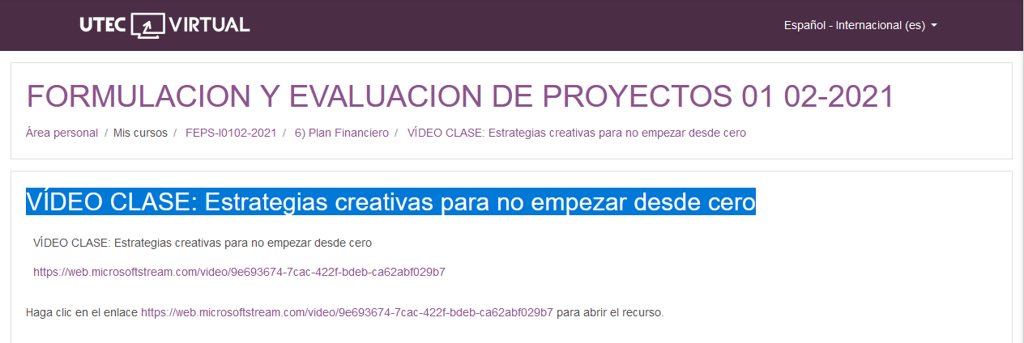

<https://web.microsoftstream.com/video/9e693674-7cac-422f-bdeb-ca62abf029b7>